DATE: 25.01.2019
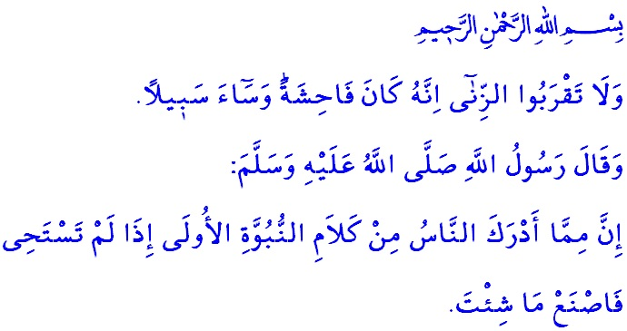HAYA’ (PIOUS SHYNESS): THE ESSENCE OF ISLAMIC MORALITY
Honorable Muslims!
The religion of Islam aims at directing the emotions in the essence of human towards better in line with the principles determined by Allah the Almighty. It puts universal principles in place for human to avoid evil and ugly words and deeds, abandon evil, and embrace good deeds. Haya’, which also reflects conscience, compassion, and a sense of shame that motivates human to avoid of misconduct, comes on top of these principles, which not only direct human closer to attaining the approval of the Lord Almighty, but also regulate human relations in the societal life.
Haya’ is an inherent human emotion making human observe the boundaries of privacy and pursue good deeds. A basic inherent human quality loved greatly by Allah, it is the ornament of faith that beautifies it. It is the most robust shield that protects believers against sins. The emotion of haya’ fills the hearts of believers with love, respect, and trust; prevents extremisms, thereby forming a peaceful society. In this respect, says our beloved Prophet (saw), “One of the sayings of the early prophets which the people have got is: If you don't feel ashamed (from Haya': pious shyness from committing religious indiscretions) do whatever you like.”
Valuable Believers!
Our Lord Almighty (swt) mentions living a chaste life among the most valuable qualities to lead human to eternal salvation, as expressed in the Holy Qur’an, “And they who guard their private parts”. Right after the command of “Tell the believing men to reduce [some] of their vision and guard their private parts. That is purer for them. Indeed, Allah is Acquainted with what they do”, He commands, “And tell the believing women to reduce [some] of their vision, guard their private parts, and not exposes their adornment…”.. In presence of Allah, all believing men and women are liable to avoid haram, and pursue a chaste life.
In an environment where societies lost moral and spiritual values in the darkness of the Jahiliyyah, our beloved Prophet (saw) insistently encouraged people to live a chaste life. In addition, after taking on the duty of prophethood, he (saw) drew attention to the unbreakable bond between faith and haya’ by stating, “The essence of Islamic morality is haya’.” He further stated, “Haya’ does not bring anything except good.”
Esteemed Muslims!
Our sublime religion Islam enjoins haya’ and modesty on the one hand, and forbids zina (fornication and adultery) that disrupts such values on the other hand. According to Islam, zina is an act that the religion regards as a grave sin, the mind as foul, and the morality as unpleasant. It is against the human nature; it damages human’s honor and self-respect. It gives a feeling of worthlessness, and breaks the ties of compassion and love. It undermines the spiritual and moral values of the society by sowing the seeds of distrust, hatred, and grudge among people.
Valued Believers!
There are many wisdoms underlying all the commandments and prohibitions established by Allah. The most important wisdom underlying the commandment of being chaste and the prohibition of fornication and adultery is the protection of the family structure because extramarital relationships both causes the collapse of the institution of family and threatens the existence of uncontaminated generations.
Honorable Muslims!
Disaster for human is deprivation and lack of chastity and modesty. It is a painful situation that distances human from attaining the approval of Allah, brings them closer to the wrath, and drags them into the never-ending frustration. Therefore, Islam forbids zina and all other acts and behaviors that lead to it. No matter how small an immoral step may look in the first place, not avoiding such steps would possibly cause one’s fall into haram. Our Sublime Lord warns us, “And do not approach unlawful sexual intercourse. Indeed, it is ever an immorality and is evil as a way.”
Esteemed Believers!
Let us be meticulous in remaining within the boundaries set by our religion and distancing ourselves from the sins. Let us strive not to make even the slightest of a mistake that may lead to moral corruption. Let us put the dress of taqwa on and equip ourselves with chastity and modesty. Let us not let it slip out of our minds that the life, the property, and the body we have are what Allah has entrusted to us, and that we all will give an account for each of these blessings. Let us not fall for the deceiving colors and the short-lived desires of the life in this world. Let us never forget that a believer who follows the path of revelation and fulfills the necessity of their faith will be glorious, and those who follow their zeal and desires will be in ignominy.

Bukhari, Adab, 78.
Mu’minun, 23/5.
Nur, 24/30.
Nur, 24/31.
Ibn Majah, Zuhd, 17.
Bukhari, Adab, 77.
Isra, 17/32. General Directorate of Religious Services

